COURSE ASSIGNMENT

1. Write a class named Point2d. Point2d should contain two member variables of type double: m_x, and m_y, both private and defaulted to 0.0. Provide a constructor and a print function.

The following program should run and display the appropriate output:

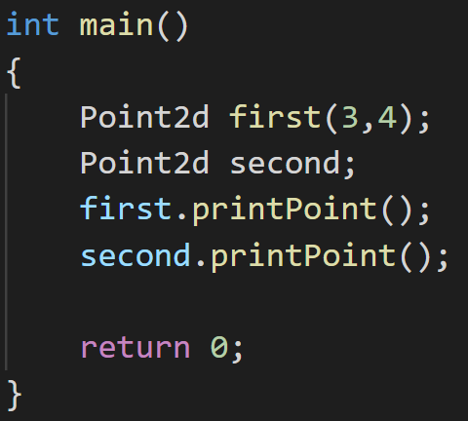

1. Now add a member function named distanceTo that takes another Point2d as a parameter, and calculates the distance between them. Given two points (x1, y1) and (x2, y2), the distance between them can be calculated as sqrt((x1 - x2)*(x1 - x2) + (y1 - y2)*(y1 - y2)). The sqrt function lives in header cmath.

The following program should run and display the appropriate output:

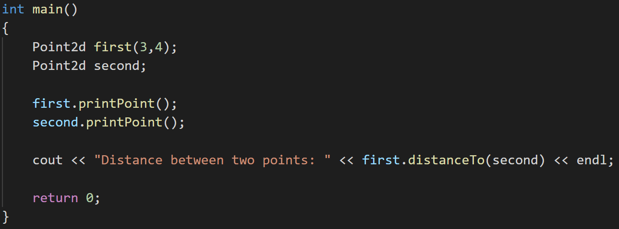

1. Change function distanceTo from a member function to a non-member friend function in a friend class that takes two Points as parameters. Also rename it “distanceFrom”.

The following program should run and display the appropriate output:

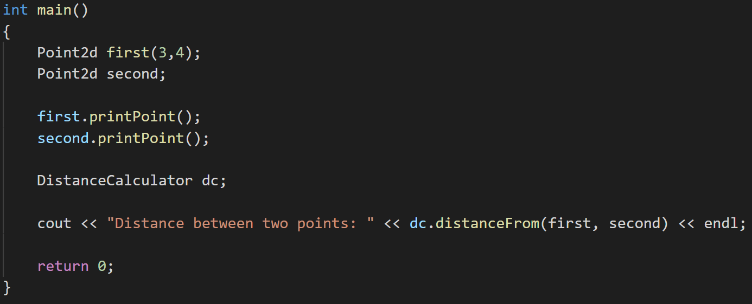

1. Write another class named Point3d which inherits from class Point2d. It should contain an addition private member variable of type double: m_z defaulted to 0.0. Provide all the above functionalities for Point3d as well.